Chapter 9, Problem 87.

The network in Fig. 9.87 is part of the schematic describing an industrial electronic sensing device. What is the total impedance of the circuit at 2 kHz?

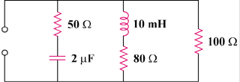

Figure 9.87
For Prob. 9.87.

